LIBRARY MANAGEMENT SYSTEM
Software Requirements Specification

Version 1.0



Group Id: <Mention your group id>
Supervisor Name :< Mention your supervisor name>

Revision History
Date (dd/mm/yyyy) | Version | Description | Author
Current date | 1.0 | The Library Management System is a web-based application developed to automate and manage library operations efficiently. It helps in maintaining records of books, members, issued books, returned books, due dates, and fines. The system reduces manual work, improves accuracy, and provides a user-friendly interface for both administrators and users. It also enables quick book searching, secure login functionality, and effective transaction management for better library services. | Write student(s) id

Table of Contents

- Scope (of the project)
- Functional Requirements Non Functional requirements
- Use Case Diagram
- Usage Scenarios
- Adopted Methodology
- Work Plan (Use MS Project to create Schedule/Work Plan)

SRS Document

Scope of Project:
The scope of the Library Management System is to provide an efficient and computerized solution for managing the daily activities of a library. The project is designed to replace the traditional manual system with an automated web-based application that improves accuracy, saves time, and reduces paperwork. The system allows administrators to manage books, members, and library transactions in an organized manner. It includes features for adding, updating, and deleting book records along with maintaining detailed information such as title, author, ISBN, and category.
The project also covers member management by allowing the admin to register new members, update their information, and remove records when required. Another important scope of the system is the management of book issuing and returning processes. The application keeps track of issued books, return dates, and overdue records automatically. It can also calculate fines for late returns, which helps in maintaining discipline and proper record keeping within the library.
In addition, the system provides secure login and authentication features for both admin and users. Users can search for books by title, author, or category and can check the availability status of books online. The system also maintains a complete history of transactions and generates reports related to issued and returned books. Overall, the scope of this project is to improve the efficiency, reliability, accessibility, and management of library services through a simple and user-friendly web application.

Functional and non Functional Requirements:

Functional Requirements

Introduction to Functional Requirements
Functional requirements describe the main features and operations that a system must perform. These requirements explain how the system should behave and what services it should provide to users and administrators. In the Library Management System, functional requirements define all activities related to managing books, members, transactions, authentication, and reporting.

Functional Requirements of Library Management System

1. Book Management
The system shall allow the administrator to add new books with complete details such as title, author name, ISBN number, category, and quantity. The administrator shall also be able to update existing book information and delete book records whenever required.

2. Member Management
The system shall provide functionality for registering new library members. The administrator shall be able to update member details and remove member records from the system when necessary.

3. Book Issuing System
The system shall allow the administrator to issue books to registered members. It shall store information about the issued book, issue date, and return due date.

4. Book Return System
The system shall provide functionality for accepting returned books and updating the availability status automatically after the return process is completed.

5. Due Date Tracking
The application shall automatically track the due dates of issued books and maintain records of overdue books.

6. Fine Calculation
The system shall automatically calculate fines for late returns based on the number of overdue days.

7. Transaction Management
The system shall maintain a complete history of all library transactions including issued books, returned books, fines, and member activities.

8. Report Generation
The administrator shall be able to generate reports related to issued books, returned books, overdue books, and fines collected.

9. User Authentication
The system shall provide secure login and logout functionality for administrators and users to ensure authorized access.

10. Book Search Functionality
Users shall be able to search books by title, author name, or category for quick access to library resources.

11. Book Availability Status
The system shall display the availability status of books so that users can check whether a book is available or already issued.

Non-Functional Requirements

Introduction to Non-Functional Requirements
Non-functional requirements describe the quality attributes and performance standards of a system. These requirements focus on how the system performs rather than what the system does. They ensure that the application is reliable, secure, efficient, and user-friendly. In the Library Management System, non-functional requirements help improve the overall performance and usability of the application.

Non-Functional Requirements of Library Management System

1. Performance
The system should provide quick response times for searching books, issuing books, and generating reports. All operations should be completed efficiently without unnecessary delays.

2. Security
The application should provide secure authentication through usernames and passwords. Only authorized users should be allowed to access administrative features and sensitive data.

3. Reliability
The system should operate accurately and consistently without data loss or system crashes during normal use.

4. Usability
The user interface should be simple, clear, and easy to understand so that administrators and users can operate the system without difficulty.

5. Maintainability
The system should be designed in a way that allows easy maintenance, updates, and future enhancements.

6. Scalability
The application should be capable of handling an increasing number of books, users, and transactions as the library grows.

7. Availability
The system should remain accessible to users whenever required, especially during library working hours.

8. Data Integrity
The system should ensure that all records related to books, members, and transactions remain accurate and consistent.

9. Compatibility
The web application should work properly on commonly used web browsers and operating systems.

Use Case Diagram(s):

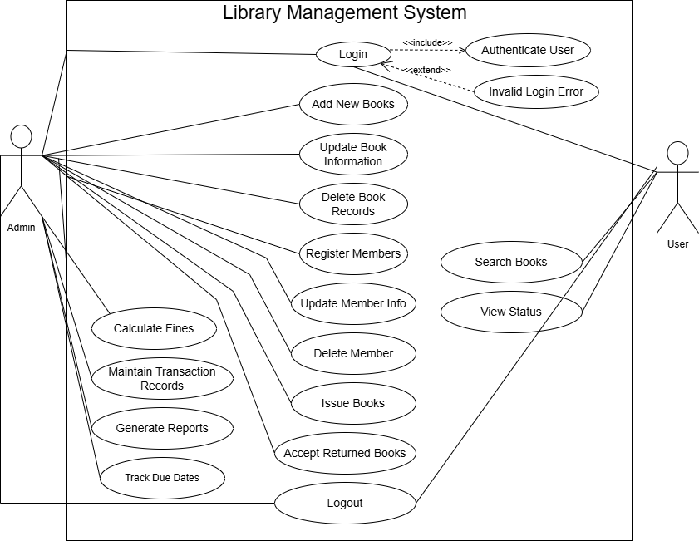

Usage Scenarios:

Use Case 1: Login
Field | Details
Use Case Title | Login
Abbreviated Title | User Login
Use Case Id | UC-01
Actors | Admin, User
Description | This use case allows the admin or user to log into the system using valid credentials.
Pre Conditions | User must be registered in the system.
Task Sequence | 1. User enters username and password. 2. System validates credentials. 3. System grants access to dashboard.
Post Conditions | User successfully logs into the system.
Author: Project ID | BC2000400080

Use Case 2: Add New Books
Field | Details
Use Case Title | Add New Books
Abbreviated Title | Add Books
Use Case Id | UC-02
Actors | Admin
Description | This use case allows the admin to add new books into the library database.
Pre Conditions | Admin must be logged into the system.
Task Sequence | 1. Admin selects add book option. 2. Admin enters book details. 3. System saves book record.
Post Conditions | New book record is added successfully.
Author: Project ID | BC2000400080

Use Case 3: Update Book Information
Field | Details
Use Case Title | Update Book Information
Abbreviated Title | Update Books
Use Case Id | UC-03
Actors | Admin
Description | This use case allows the admin to update existing book information.
Pre Conditions | Book record must exist in the database.
Task Sequence | 1. Admin searches book record. 2. Admin edits book details. 3. System updates the information.
Post Conditions | Book information is updated successfully.
Author: Project ID | BC2000400080

Use Case 4: Delete Book Records
Field | Details
Use Case Title | Delete Book Records
Abbreviated Title | Delete Books
Use Case Id | UC-04
Actors | Admin
Description | This use case allows the admin to delete book records from the system.
Pre Conditions | Selected book record must exist.
Task Sequence | 1. Admin selects a book record. 2. Admin confirms deletion. 3. System removes the record.
Post Conditions | Book record is deleted successfully.
Author: Project ID | BC2000400080

Use Case 5: Register Members
Field | Details
Use Case Title | Register Members
Abbreviated Title | Add Members
Use Case Id | UC-05
Actors | Admin
Description | This use case allows the admin to register new library members.
Pre Conditions | Admin must be logged in.
Task Sequence | 1. Admin enters member details. 2. System validates information. 3. System stores member data.
Post Conditions | New member is registered successfully.
Author: Project ID | BC2000400080

Use Case 6: Issue Books
Field | Details
Use Case Title | Issue Books
Abbreviated Title | Book Issue
Use Case Id | UC-06
Actors | Admin
Description | This use case allows the admin to issue books to library members.
Pre Conditions | Book must be available and member must be registered.
Task Sequence | 1. Admin selects member and book. 2. System checks availability. 3. System issues book and assigns due date.
Post Conditions | Book is issued successfully.
Author: Project ID | BC2000400080

Use Case 7: Return Books
Field | Details
Use Case Title | Return Books
Abbreviated Title | Book Return
Use Case Id | UC-07
Actors | Admin
Description | This use case allows the admin to accept returned books from members.
Pre Conditions | Book must be issued previously.
Task Sequence | 1. Admin selects issued book record. 2. System checks return date. 3. System updates availability status.
Post Conditions | Book return is completed successfully.
Author: Project ID | BC2000400080

Use Case 8: Calculate Fine
Field | Details
Use Case Title | Calculate Fine
Abbreviated Title | Fine Calculation
Use Case Id | UC-08
Actors | System
Description | This use case allows the system to calculate fines for overdue books automatically.
Pre Conditions | Returned book must be overdue.
Task Sequence | 1. System compares due date with return date. 2. System calculates overdue days. 3. System generates fine amount.
Post Conditions | Fine amount is calculated successfully.
Author: Project ID | BC2000400080

Use Case 9: Search Books
Field | Details
Use Case Title | Search Books
Abbreviated Title | Book Search
Use Case Id | UC-09
Actors | User
Description | This use case allows users to search books by title, author, or category.
Pre Conditions | User must be logged into the system.
Task Sequence | 1. User enters search keyword. 2. System searches database. 3. System displays matching books.
Post Conditions | Search results are displayed successfully.
Author: Project ID | BC2000400080

Use Case 10: View Book Availability
Field | Details
Use Case Title | View Book Availability
Abbreviated Title | Availability Status
Use Case Id | UC-10
Actors | User
Description | This use case allows users to view the availability status of books.
Pre Conditions | Book record must exist in the system.
Task Sequence | 1. User searches for a book. 2. System checks book status. 3. System displays availability information.
Post Conditions | User can view whether the book is available or issued.
Author: Project ID | BC2000400080

Use Case 11: Update Member Information
Field | Details
Use Case Title | Update Member Information
Abbreviated Title | Update Members
Use Case Id | UC-11
Actors | Admin
Description | This use case allows the admin to update information of existing library members.
Pre Conditions | Member record must exist in the system.
Task Sequence | 1. Admin searches member record. 2. Admin edits member details. 3. System saves updated information.
Post Conditions | Member information is updated successfully.
Author: Project ID | BC2000400080

Use Case 12: Delete Member Records
Field | Details
Use Case Title | Delete Member Records
Abbreviated Title | Delete Members
Use Case Id | UC-12
Actors | Admin
Description | This use case allows the admin to delete member records from the system.
Pre Conditions | Member record must exist in the database.
Task Sequence | 1. Admin selects member record. 2. Admin confirms deletion. 3. System removes member data.
Post Conditions | Member record is deleted successfully.
Author: Project ID | BC2000400080

Use Case 13: Track Due Dates
Field | Details
Use Case Title | Track Due Dates
Abbreviated Title | Due Date Tracking
Use Case Id | UC-13
Actors | Admin, System
Description | This use case allows the system and admin to monitor due dates of issued books.
Pre Conditions | Books must be issued to members.
Task Sequence | 1. System checks issued book records. 2. System compares current date with due date. 3. System displays overdue books list.
Post Conditions | Due dates are tracked successfully.
Author: Project ID | BC2000400080

Use Case 14: Maintain Transaction Records
Field | Details
Use Case Title | Maintain Transaction Records
Abbreviated Title | Transactions
Use Case Id | UC-14
Actors | Admin, System
Description | This use case allows the system to maintain records of all library transactions.
Pre Conditions | Any issue or return transaction must occur.
Task Sequence | 1. System records issue/return details. 2. System stores transaction history. 3. Admin can access transaction records.
Post Conditions | Transaction records are maintained successfully.
Author: Project ID | BC2000400080

Use Case 15: Generate Reports
Field | Details
Use Case Title | Generate Reports
Abbreviated Title | Reports
Use Case Id | UC-15
Actors | Admin
Description | This use case allows the admin to generate reports for issued and returned books.
Pre Conditions | Transaction records must exist in the database.
Task Sequence | 1. Admin selects report type. 2. System collects required data. 3. System generates and displays report.
Post Conditions | Reports are generated successfully.
Author: Project ID | BC2000400080

Use Case 16: Logout
Field | Details
Use Case Title | Logout
Abbreviated Title | User Logout
Use Case Id | UC-16
Actors | Admin, User
Description | This use case allows users to securely logout from the system.
Pre Conditions | User must be logged into the system.
Task Sequence | 1. User selects logout option. 2. System ends user session. 3. System redirects to login page.
Post Conditions | User is logged out successfully.
Author: Project ID | BC2000400080

Use Case 17: Automatically Track Due Dates
Field | Details
Use Case Title | Automatically Track Due Dates
Abbreviated Title | Auto Due Tracking
Use Case Id | UC-17
Actors | System
Description | This use case allows the system to automatically monitor due dates of issued books.
Pre Conditions | Issued book records must exist.
Task Sequence | 1. System scans issued books database. 2. System identifies overdue books. 3. System updates overdue status.
Post Conditions | Overdue books are identified automatically.
Author: Project ID | BC2000400080

Use Case 18: Automatically Calculate Fines
Field | Details
Use Case Title | Automatically Calculate Fines
Abbreviated Title | Auto Fine Calculation
Use Case Id | UC-18
Actors | System
Description | This use case allows the system to automatically calculate fines for overdue books.
Pre Conditions | Returned books must exceed due date.
Task Sequence | 1. System checks overdue duration. 2. System calculates fine according to rules. 3. System stores fine amount in records.
Post Conditions | Fine amount is generated automatically.
Author: Project ID | BC2000400080

UC-19: User Authentication
Field | Details
Use Case Title | User Authentication
Abbreviated Title | Authentication
Use Case Id | UC-19
Actors | System
Description | This use case verifies the username and password entered by the user or admin.
Pre Conditions | User/Admin must enter login credentials.
Task Sequence | 1. User enters credentials.  2. System validates username and password.  3. System grants or denies access.
Post Conditions | Authorized user gets access to the system.
Author: Project ID | BC2000400080

UC-20: Validate Book Availability
Field | Details
Use Case Title | Validate Book Availability
Abbreviated Title | Check Availability
Use Case Id | UC-20
Actors | System
Description | This use case checks whether the requested book is available for issuing.
Pre Conditions | Book record must exist in the database.
Task Sequence | 1. Admin/User selects a book.  2. System checks issue status.  3. System displays availability result.
Post Conditions | Availability status is verified successfully.
Author: Project ID | BC2000400080

UC-21: Store Fine Records
Field | Details
Use Case Title | Store Fine Records
Abbreviated Title | Fine Records
Use Case Id | UC-21
Actors | System
Description | This use case stores calculated fine details into the database.
Pre Conditions | Fine amount must be calculated.
Task Sequence | 1. System receives fine amount.  2. System links fine with member record.  3. System saves fine details.
Post Conditions | Fine records are stored successfully.
Author: Project ID | BC2000400080

UC-22: View Issued Books Report
Field | Details
Use Case Title | View Issued Books Report
Abbreviated Title | Issued Report
Use Case Id | UC-22
Actors | Admin
Description | This use case allows the admin to view reports of all issued books.
Pre Conditions | Issued book records must exist.
Task Sequence | 1. Admin selects issued books report option.  2. System fetches issued records.  3. System displays report.
Post Conditions | Issued books report is generated successfully.
Author: Project ID | BC2000400080

UC-23: View Returned Books Report
Field | Details
Use Case Title | View Returned Books Report
Abbreviated Title | Returned Report
Use Case Id | UC-23
Actors | Admin
Description | This use case allows the admin to view reports of returned books.
Pre Conditions | Returned book records must exist.
Task Sequence | 1. Admin selects returned books report option.  2. System collects returned records.  3. System generates report.
Post Conditions | Returned books report is displayed successfully.
Author: Project ID | BC2000400080

UC-24: Update Book Availability Status
Field | Details
Use Case Title | Update Book Availability Status
Abbreviated Title | Update Availability
Use Case Id | UC-24
Actors | System
Description | This use case updates the availability status of books after issue or return.
Pre Conditions | Book issue or return transaction must occur.
Task Sequence | 1. System detects transaction.  2. System updates book quantity/status.  3. System saves updated status.
Post Conditions | Book availability status is updated successfully.
Author: Project ID | BC2000400080

Adopted Methodology
For the development of the Library Management System, the VU Process Model has been adopted. The VU Process Model is a hybrid software development methodology that combines the features of both the Waterfall Model and the Spiral Model. This methodology provides the advantages of a structured and sequential development process while also supporting iterative improvement and risk handling. It is suitable for academic software projects because it ensures proper documentation, organized development phases, and continuous refinement of the system.
The Waterfall Model contributes a step-by-step development approach where each phase is completed before moving to the next phase. On the other hand, the Spiral Model adds flexibility by allowing repeated evaluation, testing, and improvement during development. By combining these two models, the VU Process Model helps in developing reliable, efficient, and user-oriented software systems.
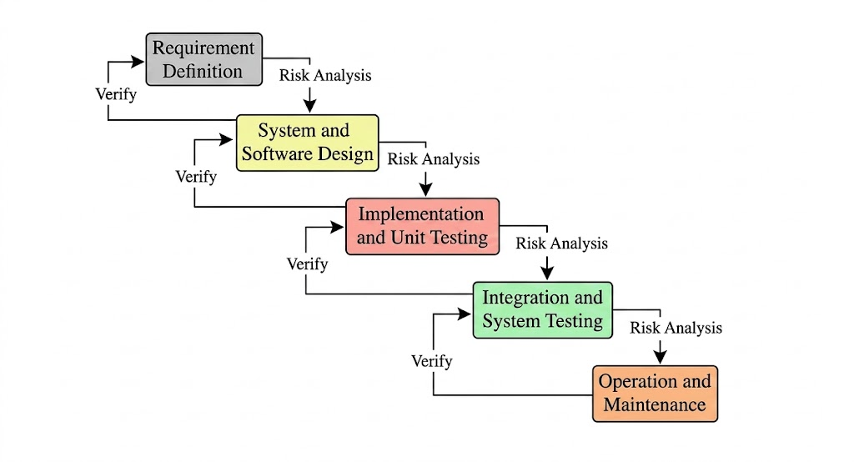

Waterfall Model
The Waterfall Model is a traditional software development methodology in which the development process follows a linear and sequential flow. In this model, each phase must be completed before the next phase begins, and there is no overlap between stages. The process starts with requirement analysis, where all system requirements are collected and documented. After that, system design is prepared, which defines the architecture, database structure, and interface layout. The next stage is implementation, where the actual coding of the system is done according to the design. Once development is completed, the system is tested to identify and fix errors. After successful testing, the system is deployed for use, and finally, maintenance is performed to handle updates and issues. The Waterfall Model is simple, easy to understand, and well-structured, but it is less flexible because changes are difficult to implement once a phase is completed. It is suitable for small and clearly defined projects.
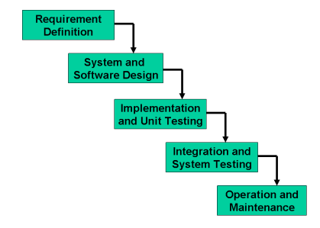

Spiral Model
The Spiral Model is a risk-driven and iterative software development methodology that combines elements of both prototyping and systematic development. In this model, the system is developed in repeated cycles called spirals, where each cycle improves and enhances the system based on feedback and evaluation. Each spiral consists of four main activities: planning, risk analysis, engineering, and evaluation. In the planning phase, requirements and objectives are defined. During risk analysis, potential risks are identified and solutions are planned to minimize them. In the engineering phase, the system is designed, coded, and tested in parts. In the evaluation phase, users review the system and provide feedback for further improvement. The Spiral Model is highly flexible and allows continuous refinement, making it suitable for large and complex projects. It provides strong risk management and better quality control, but it is more complex and expensive compared to other models.
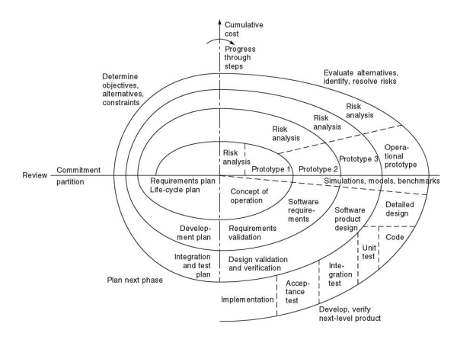

Reasons to Choose VU Process Model
- Combination of Waterfall and Spiral Models
The VU Process Model is selected because it integrates the structured nature of the Waterfall Model with the iterative and flexible nature of the Spiral Model. This combination helps in maintaining proper discipline in development while also allowing improvements at different stages of the project.
- Clear and Well-Organized Development Process
This model provides a step-by-step structured approach where each phase is completed before moving to the next. It helps in clearly understanding requirements, designing the system properly, and implementing it in an organized way, which reduces confusion during development.
- Continuous Improvement Through Iterations
The VU Process Model supports repeated evaluation and refinement of the system. After each phase, feedback can be used to improve the system, which ensures that the final product is more accurate, efficient, and closer to user requirements.
- Early Detection of Errors and Risk Management
Since testing and evaluation are performed throughout the development process, errors and risks are identified at an early stage. This reduces the chances of major problems in the final system and improves overall software quality and reliability.
- Better Documentation and Project Control
Every phase of the VU Process Model is properly documented, which makes it easier to track progress and manage the project. This documentation also helps in future maintenance and upgrades, ensuring that the system can be improved or modified when required.

Work Plan (Use MS Project to create Schedule/Work Plan)

